Wiki osp-jmeter

Overview
"osp-jmeter" is the simple and fast way to run various workloads on Openstack deployment. Basically, it is a collection of Ansible playbooks, JMeter scripts and xsl templates which:
- generate workload on Openstack deployment using REST APIs calls or Web HTTP requests to Horizon Dashboard
- stress a Openstack instances in various selectable ways using stress-ng and iperf tools
- perform specific system test cases under Control and Data plane load
- measure various response times and collect other statistics during the tests
- generate informative reports
- compare test results and generate comparison report
Supported environments:
- Operating systems - RHEL 7.*, CentOS 7.*
- Openstack: RHOS 10/11/12/13, Newton/Ocata/Pike/Queens
- Openstack security: SSL / no SSL

Test cases:

REST API Sanity Functional Test.
The purpose of the test is to verify the basic Openstack functionality using REST API calls to Keystone, Neutron, Nova, Glance and Cinder. Test simulate a logical flow which create Project, User, Network, Volume, Image, Instance and manipulate with them. Test remove all created entities in the end. Test script collect various data during a test running such as Pass/Fail criteria, Response Code, Response Message, Sent Bytes, Response Time and Request/Response Data.
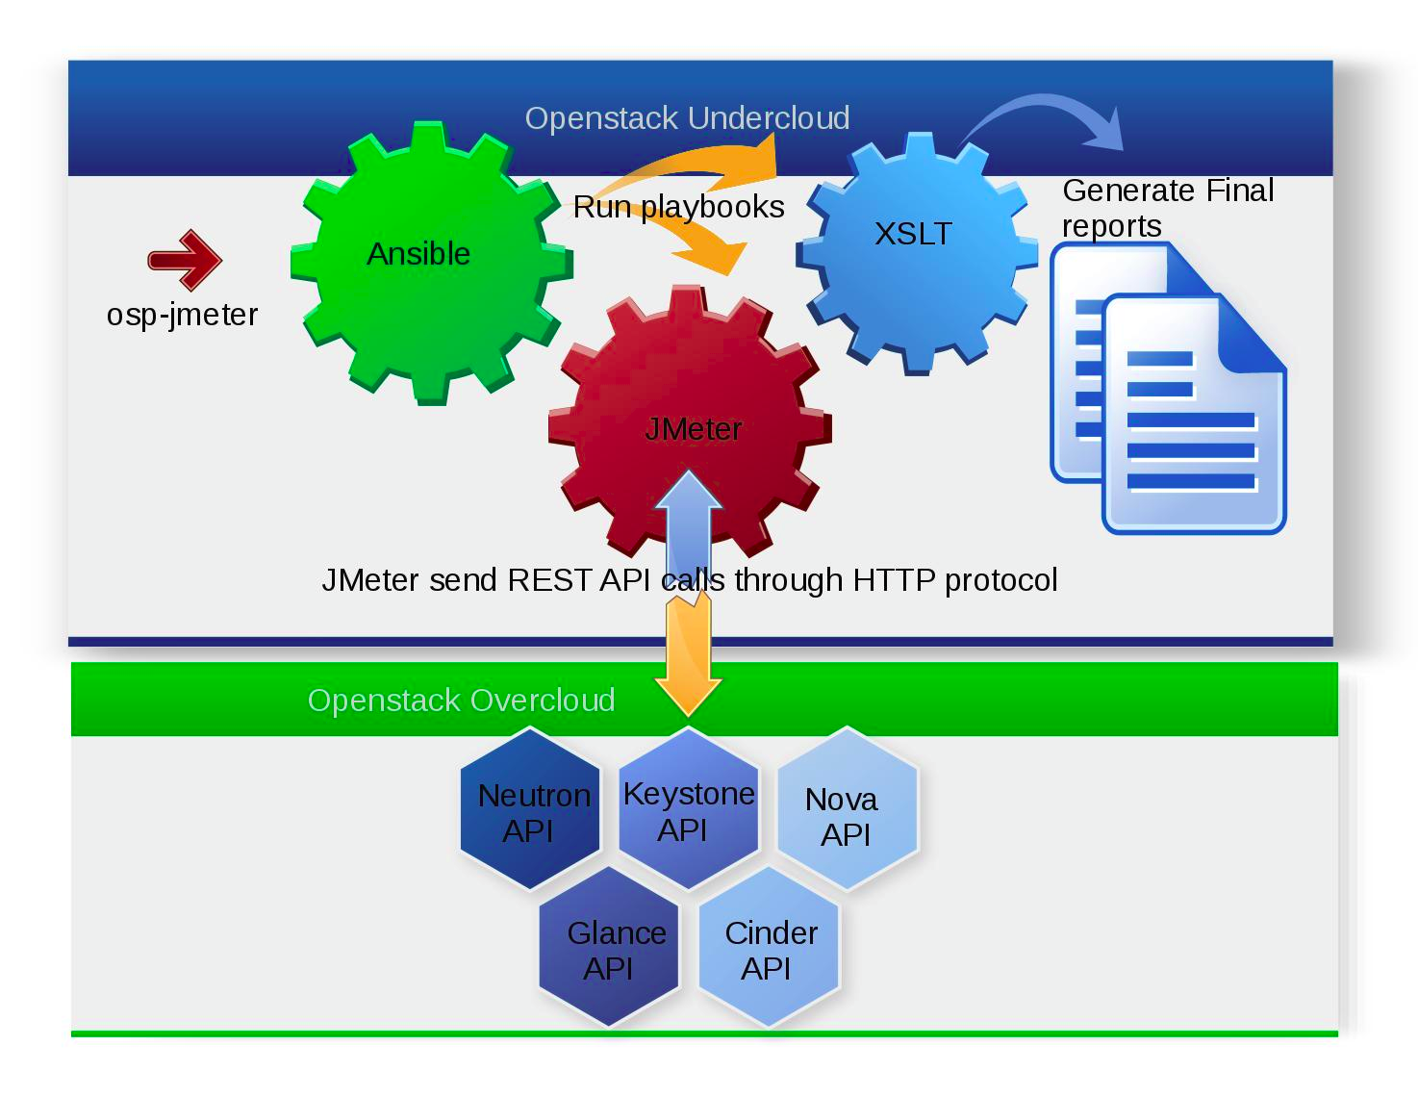
Test scenario (REST API):
- 01.KEYSTONE.POST.Admin.Token
- 02.KEYSTONE.GET.Admin.Tenant
- 03.KEYSTONE.GET.List.Tenant
- 04.KEYSTONE.POST.Create.Tenant
- 05.KEYSTONE.GET.List.User
- 06.KEYSTONE.POST.Create.User
- 07.KEYSTONE.GET.Search.Admin.Role
- 08.KEYSTONE.PUT.Grant.Admin.Role
- 09.KEYSTONE.POST.Tenant.Token
- 10.NOVA.GET.Search.Image
- 11.NOVA.GET.Search.Flavor
- 12.CINDER.GET.List.Volume
- 13.CINDER.POST.Create.Volume
- 14.CINDER.GET.Volume.Details
- 15.NEUTRON.Get.List.Network
- 16.NEUTRON.POST.Create.Network
- 17.NEUTRON.Get.List.Subnet
- 18.NEUTRON.POST.Create.Subnet
- 19.NOVA.GET.List.Server
- 20.NOVA.POST.Boot.Server
- 21.NOVA.GET.Server.Details
- 22.CINDER.POST.Attach.Volume
- 23.NOVA.PUT.Update.Server
- 24.NOVA.POST.Pause.Server
- 25.NOVA.POST.Unpause.Server
- 26.NOVA.POST.Suspend.Server
- 27.NOVA.POST.Resume.Server
- 28.NOVA.POST.Soft.Reboot.Server
- 29.NOVA.POST.Hard.Reboot.Server
- 30.NOVA.POST.Stop.Server
- 31.NOVA.POST.Start.Server
- 32.NOVA.POST.Create.Snapshot
- 33.NOVA.GET.Search.Snapshot
- 34.NOVA.DELETE.Snapshot
- 35.GLANCE.GET.List.Image
- 36.GLANCE.POST.Create.Image
- 37.GLANCE.PATCH.Update.Image
- 38.GLANCE.GET.Image.Details
- 39.GLANCE.DELETE.Image
- 40.CINDER.GET.Search.Volume
- 41.CINDER.POST.Dettach.Volume
- 42.CINDER.DELETE.Volume
- 43.NOVA.DELETE.Server
- 44.NOVA.GET.Search.Server
- 45.NEUTRON.GET.Search.Subnet
- 46.NEUTRON.DELETE.Subnet
- 47.NEUTRON.GET.Search.Network
- 48.NEUTRON.DELETE.Network
- 49.KEYSTONE.DELETE.Tenant
- 50.KEYSTONE.DELETE.User

REST API Sanity Performance Test.
The purpose of the test is to verify the basic Openstack performance using REST API calls to Keystone, Neutron, Nova, Glance and Cinder in cycle manner using predefined amount of concurrent threads.Test simulate a similar to Sanity Functional Test logical flow.Test script collect various data during the test running such as REST API calls Response Time, Transactions Elapsed Time and System statistics ( CPU, Memory, Network and Disk Utilization) when PerfMon is enabled.
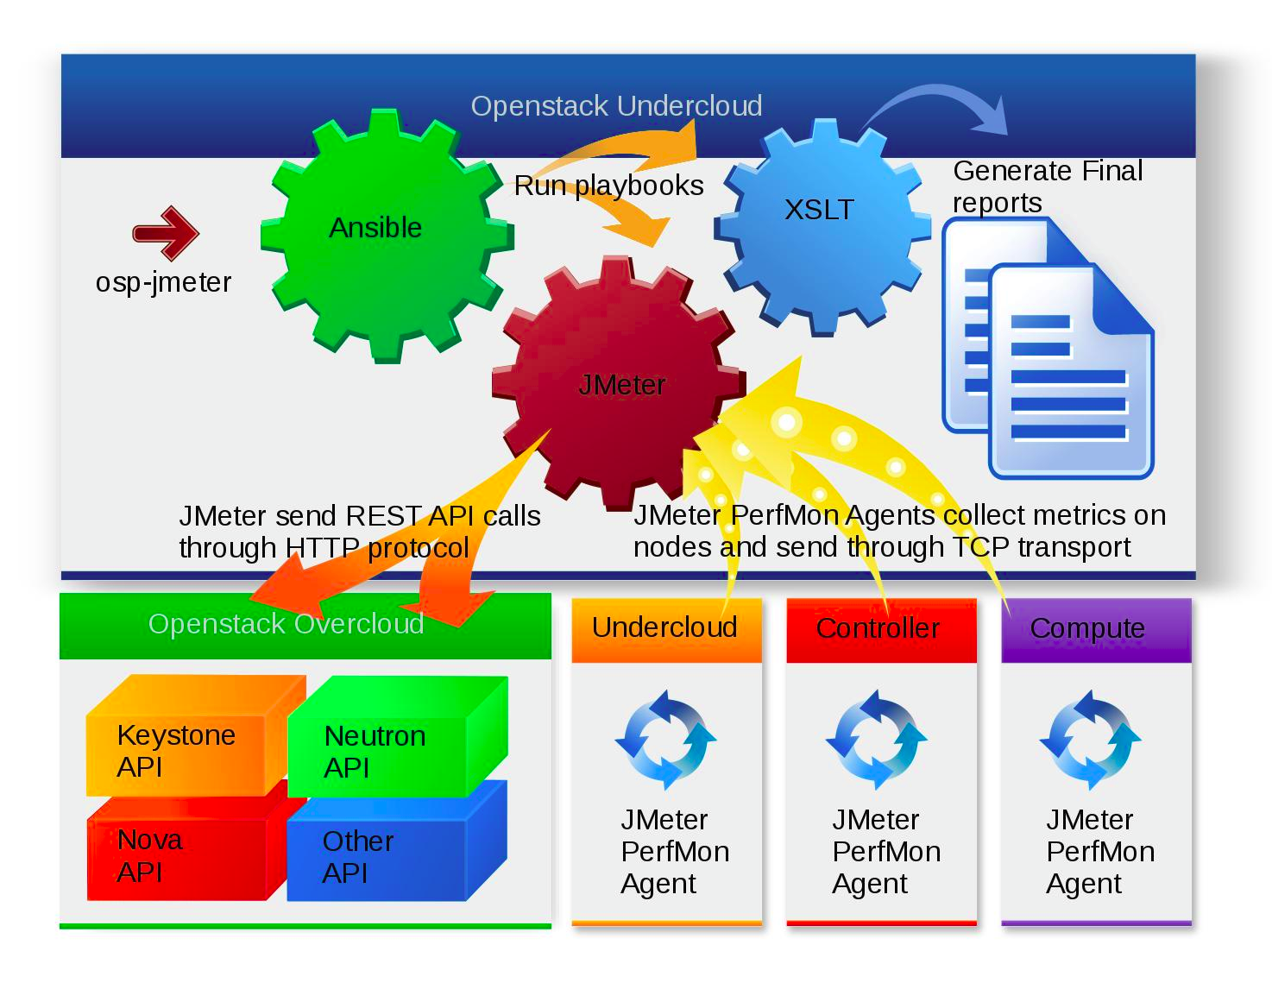
Test scenario (REST API):
- 01.KEYSTONE.POST.Admin.Token
- 02.KEYSTONE.GET.Admin.Tenant
- 03.KEYSTONE.GET.List.Tenant
- 04.KEYSTONE.POST.Create.Tenant
- 05.KEYSTONE.GET.List.User
- 06.KEYSTONE.POST.Create.User
- 07.KEYSTONE.GET.Search.Admin.Role
- 08.KEYSTONE.PUT.Grant.Admin.Role
- 09.KEYSTONE.POST.Tenant.Token
- 10.NOVA.GET.Search.Image
- 11.NOVA.GET.Search.Flavor
- 12.CINDER.GET.List.Volume
- 13.CINDER.POST.Create.Volume
- 14.CINDER.GET.Volume.Details
- 15.NEUTRON.Get.List.Network
- 16.NEUTRON.POST.Create.Network
- 17.NEUTRON.Get.List.Subnet
- 18.NEUTRON.POST.Create.Subnet
- 19.NOVA.GET.List.Server
- 20.NOVA.POST.Boot.Server
- 21.NOVA.GET.Server.Details
- 22.CINDER.POST.Attach.Volume
- 23.NOVA.PUT.Update.Server
- 24.NOVA.POST.Pause.Server
- 25.NOVA.POST.Unpause.Server
- 26.NOVA.POST.Suspend.Server
- 27.NOVA.POST.Resume.Server
- 28.NOVA.POST.Soft.Reboot.Server
- 29.NOVA.POST.Hard.Reboot.Server
- 30.NOVA.POST.Stop.Server
- 31.NOVA.POST.Start.Server
- 32.NOVA.POST.Create.Snapshot
- 33.NOVA.GET.Search.Snapshot
- 34.NOVA.DELETE.Snapshot
- 35.GLANCE.GET.List.Image
- 36.GLANCE.POST.Create.Image
- 37.GLANCE.PATCH.Update.Image
- 38.GLANCE.GET.Image.Details
- 39.GLANCE.DELETE.Image
- 40.CINDER.GET.Search.Volume
- 41.CINDER.POST.Dettach.Volume
- 42.CINDER.DELETE.Volume
- 43.NOVA.DELETE.Server
- 44.NOVA.GET.Search.Server
- 45.NEUTRON.GET.Search.Subnet
- 46.NEUTRON.DELETE.Subnet
- 47.NEUTRON.GET.Search.Network
- 48.NEUTRON.DELETE.Network
- 49.KEYSTONE.DELETE.Tenant
- 50.KEYSTONE.DELETE.User
Test scenario (Transactions):
- 13.CINDER.POST.Create.Volume.Trx
- 20.NOVA.POST.Boot.Server.Trx
- 22.CINDER.POST.Attach.Volume.Trx
- 24.NOVA.POST.Pause.Server.Trx
- 25.NOVA.POST.Unpause.Server.Trx
- 26.NOVA.POST.Suspend.Server.Trx
- 27.NOVA.POST.Resume.Server.Trx
- 28.NOVA.POST.Soft.Reboot.Server.Trx
- 29.NOVA.POST.Hard.Reboot.Server.Trx
- 30.NOVA.POST.Stop.Server.Trx
- 31.NOVA.POST.Start.Server.Trx
- 32.NOVA.POST.Create.Snapshot.Trx
- 41.CINDER.POST.Dettach.Volume.Trx
- 43.NOVA.DELETE.Server.Trx

REST API Stress Test.
The purpose of the test is to verify the Openstack stability and performance under a workload running on Instances using tools such as stress-ng and iperf3. Test create Instances and all required entities using REST API calls to Keystone, Neutron, Nova using predefined amount of concurrent threads. Once the connectivity to Instances is ready the test start a workload on each Instance for a predefined duration and load. Test script collect various data during the test running such as REST API calls Response Time, Transactions Elapsed Time and System statistics ( CPU, Memory, Network and Disk Utilization) when PerfMon enabled.
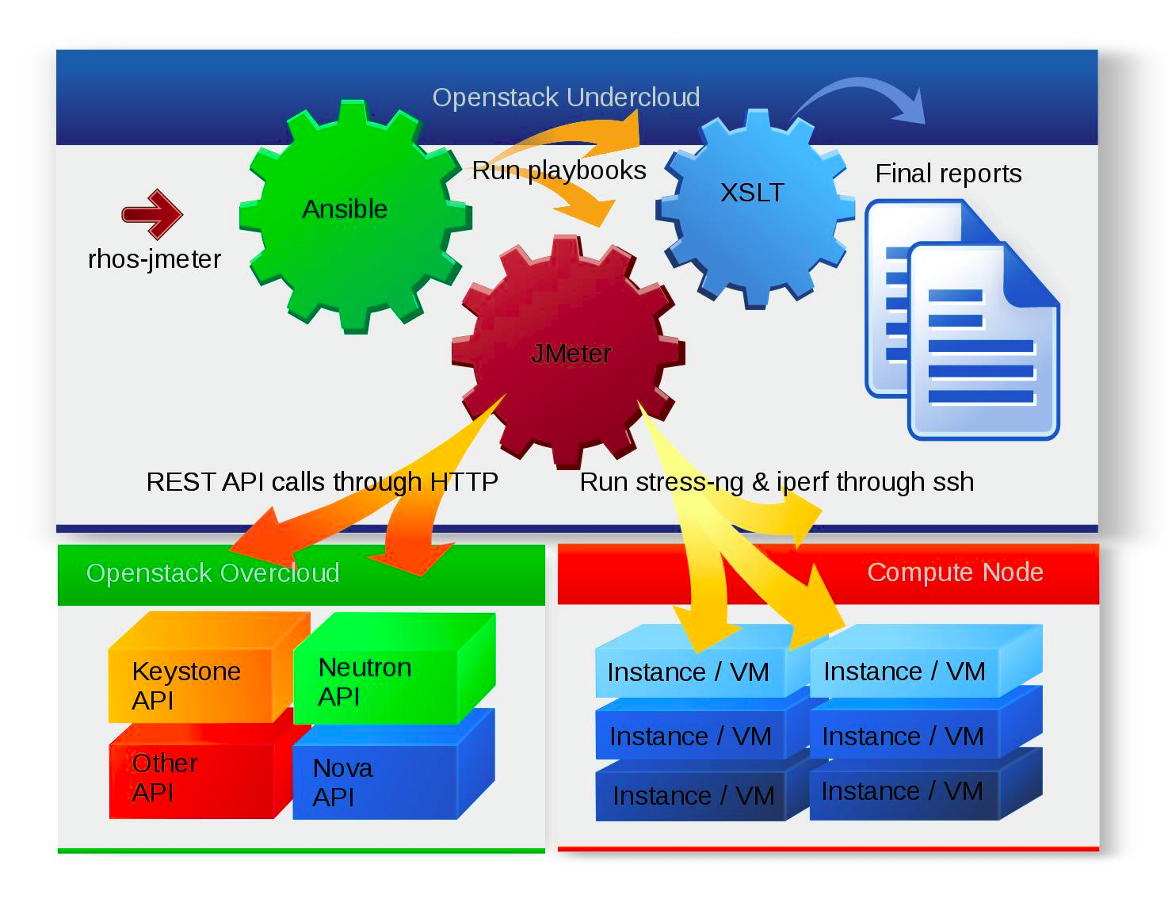
Test scenario (REST API):
- 01.KEYSTONE.POST.Admin.Token
- 02.KEYSTONE.GET.Admin.Tenant
- 03.KEYSTONE.GET.List.Tenant
- 04.KEYSTONE.POST.Create.Tenant
- 05.KEYSTONE.GET.List.User
- 06.KEYSTONE.POST.Create.User
- 07.KEYSTONE.GET.Search.Admin.Role
- 08.KEYSTONE.PUT.Grant.Admin.Role
- 09.KEYSTONE.POST.Tenant.Token
- 10.NOVA.GET.Search.Image
- 11.NOVA.GET.Search.Flavor
- 12.NEUTRON.Get.Security.Group
- 13.NEUTRON.POST.Create.Security.Group
- 14.NEUTRON.POST.Create.Sec.Group.Rule.SSH
- 15.NEUTRON.POST.Create.Sec.Group.Rule.PING
- 16.NEUTRON.Get.External.Network
- 17.NEUTRON.POST.Create.Network
- 18.NEUTRON.POST.Create.Subnet
- 19.NEUTRON.POST.Create.Floating.IP
- 20.NEUTRON.POST.Create.Router
- 21.NEUTRON.PUT.Add.Interface.To.Router
- 22.NOVA.POST.Import.Keypair
- 23.NOVA.POST.Boot.Server
- 24.NOVA.GET.Server.Details
- 25.NOVA.POST.Add.Floating.IP
- 26.SSH.PING.Instance
- 27.SSH.DATE.On.Instance
- 28.SSH.UPDATE.IPTABLES.On.UC
- 29.SSH.UPDATE.IPTABLES.On.UC
- 30.SSH.START.IPERF.SRV.On.UC
- 31.SSH.YUM.RPM.On.Instance
- 32.SSH.YUM.REPO.On.Instance
- 33.SSH.YUM.IPERF.On.Instance
- 34.SSH.RPM.EPEL.On.Instance
- 35.SSH.YUM.STRESS-NG.On.Instance
- 36.SSH.STRESS.On.Instance
- 37.NOVA.POST.Remove.Floating.IP
- 38.NOVA.DELETE.Server
- 39.NOVA.GET.Search.Server
- 40.NOVA.DELETE.Keypair
- 41.NEUTRON.PUT.Remove.Interface.From.Router
- 42.NEUTRON.DELETE.Router
- 43.NEUTRON.DELETE.Security.Group
- 44.NEUTRON.DELETE.Floating.IP
- 45.NEUTRON.DELETE.Subnet
- 46.NEUTRON.DELETE.Network
- 47.KEYSTONE.DELETE.User
- 48.KEYSTONE.DELETE.Tenant
- 49.SSH.GET.IPERF.PID.On.UC
- 50.SSH.KILL.IPERF.On.UC
Test scenario (Transactions):
- 23.NOVA.POST.Boot.Server.Trx
- 38.NOVA.DELETE.Server.Trx

HTTP Horizon Sanity Functional Test.
The purpose of the test is to verify the basic Openstack Horizon Dashboard functionality using HTTP requests. Test simulate a logical flow which create Project, User, Network, Volume, Image, Instance and manipulate with them. Test remove all created entities in the end. Test script collect various data during a test running such as Pass/Fail criteria, Response Code, Response Message, Sent Bytes, Response Time and Request/Response Data.
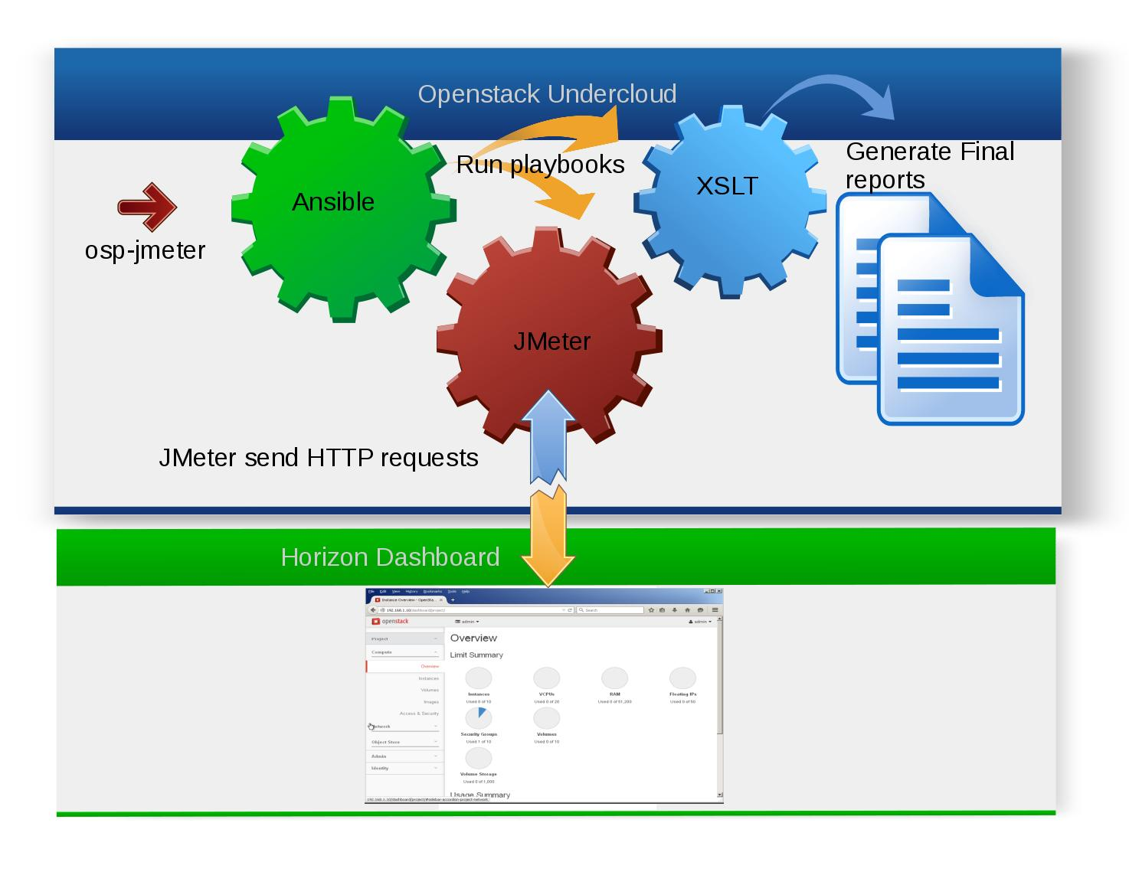
Test scenario (Web requests):
- 01.UI.Identity.Navigate
- 02.UI.Identity.Login
- 03.UI.Identity.Projects
- 04.UI.Identity.Create.Project
- 05.UI.Identity.Users
- 06.UI.Identity.CreateUser
- 07.UI.Identity.Home
- 08.UI.Identity.Logout
- 09.UI.Project.Navigate
- 10.UI.Project.Login
- 11.UI.Project.Volumes
- 12.UI.Project.Create.Volume
- 13.UI.Project.Volume.Status
- 14.UI.Project.Images
- 15.UI.Project.Create.Image
- 16.UI.Project.Image.Status
- 17.UI.Project.Networks
- 18.UI.Project.Create.Network
- 19.UI.Project.Instances
- 20.UI.Project.Launch.Instance
- 21.UI.Project.Instance.Status
- 22.UI.Proj.Instance.Attach.Volume
- 23.UI.Project.Pause.Instance
- 24.UI.Project.Resume.Paused.Instance
- 25.UI.Project.Suspend.Instance
- 26.UI.Project.Resume.Suspended.Instance
- 27.UI.Project.SoftReboot.Instance
- 28.UI.Project.HardReboot.Instance
- 29.UI.Project.Shutdown.Instance
- 30.UI.Project.Start.Instance
- 31.UI.Project.Instance.Create.Snapshot
- 32.UI.Project.Snapshot.Status
- 33.UI.Project.Delete.Snapshot
- 34.UI.Project.Delete.Image
- 35.UI.Project.Instance.Detach.Volume
- 36.UI.Project.Delete.Volume
- 37.UI.Project.Delete.Instance
- 38.UI.Project.Delete.Network
- 39.UI.Project.Project
- 40.UI.Project.Logout
- 41.UI.Identity.Delete.User
- 42.UI.Identity.Delete.Project

HTTP Horizon Sanity Performance Test:
The purpose of the test is to verify the basic Openstack Horizon Dashboard performance using HTTP requests in cycle manner using predefined amount of concurrent threads.Test simulate a similar to Sanity Functional Test logical flow.Test script collect various data during the test running such as HTTP requests Response Time, Transactions Elapsed Time and System statistics ( CPU, Memory, Network and Disk Utilization) when PerfMon is enabled
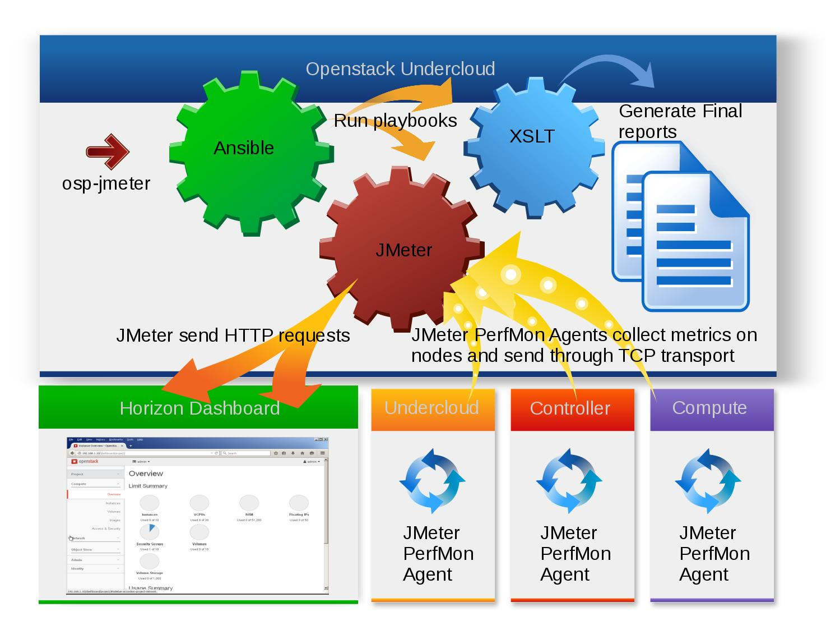
Test scenario (Web requests):
- 01.UI.Identity.Navigate
- 02.UI.Identity.Login
- 03.UI.Identity.Projects
- 04.UI.Identity.Create.Project
- 05.UI.Identity.Users
- 06.UI.Identity.CreateUser
- 07.UI.Identity.Home
- 08.UI.Identity.Logout
- 09.UI.Project.Navigate
- 10.UI.Project.Login
- 11.UI.Project.Volumes
- 12.UI.Project.Create.Volume
- 13.UI.Project.Volume.Status
- 14.UI.Project.Images
- 15.UI.Project.Create.Image
- 16.UI.Project.Image.Status
- 17.UI.Project.Networks
- 18.UI.Project.Create.Network
- 19.UI.Project.Instances
- 20.UI.Project.Launch.Instance
- 21.UI.Project.Instance.Status
- 22.UI.Proj.Instance.Attach.Volume
- 23.UI.Project.Pause.Instance
- 24.UI.Project.Resume.Paused.Instance
- 25.UI.Project.Suspend.Instance
- 26.UI.Project.Resume.Suspended.Instance
- 27.UI.Project.SoftReboot.Instance
- 28.UI.Project.HardReboot.Instance
- 29.UI.Project.Shutdown.Instance
- 30.UI.Project.Start.Instance
- 31.UI.Project.Instance.Create.Snapshot
- 32.UI.Project.Snapshot.Status
- 33.UI.Project.Delete.Snapshot
- 34.UI.Project.Delete.Image
- 35.UI.Project.Instance.Detach.Volume
- 36.UI.Project.Delete.Volume
- 37.UI.Project.Delete.Instance
- 38.UI.Project.Delete.Network
- 39.UI.Project.Project
- 40.UI.Project.Logout
- 41.UI.Identity.Delete.User
- 42.UI.Identity.Delete.Project

Test scenario (Web transactions):
- 12.UI.Project.Create.Volume.Trx
- 15.UI.Project.Create.Image.Trx
- 20.UI.Proj.Launch.Instance.Trx
- 22.UI.Proj.Instance.Attach.Volume.Trx
- 23.UI.Proj.Pause.Instance.Trx
- 24.UI.Proj.Resume.Paused.Instance.Trx
- 25.UI.Proj.Suspend.Instance.Trx
- 26.UI.Proj.Resume.Suspended.Instance.Trx
- 27.UI.Proj.SoftReboot.Instance.Trx
- 28.UI.Proj.HardReboot.Instance.Trx
- 29.UI.Proj.Shutdown.Instance.Trx
- 30.UI.Proj.Start.Instance.Trx
- 31.UI.Proj.Instance.Create.Snapshot.Trx

System Test:
The purpose of the test is to test specific test cases under Control and Data planes load. Test create Cloud and all required entities. Once the Cloud is ready the test start Control plane load using REST API calls and Data plane load using ping to Instances and execute write/read operation on Instance. After some delay test perform selected test case (live migration, reboot controller,etc) and wait till case will be completed. Test script collect various data during the test running such as REST API calls Response Time, Transactions Elapsed Time and System statistics ( CPU, Memory, Network and Disk Utilization) when PerfMon enabled.
Test scenario (REST API):

